Software Requirements Specification
For
Organic Dairy Farming- ERP System
Version 1.0 approved
Group: Aakriti Arya
Aman Jain
Ashwin Jayadev
Hrithik Puri
Deep Parikh

NIIT University
Date : 20/09/2016

Introduction

Purpose
The purpose of this document is to present a detailed description of the Organic Dairy Farming ERP system. It will explain the purpose and features of the system, the interfaces of the system, what the system will do, the constraints under which it must operate and how the system will react to external stimuli. This document is intended for both the stakeholders and the developers of the system.

Document Conventions
This document conventions:
Font: Arial
Font-size: 18 (Main Headings)
14 (Sub- Headings)
12 (paragraphs)

Every requirement statement is to have its own priority.

Intended Audience and Reading Suggestions

The intended audience for the document is Owner of the company, developers, marketing staff, and other stakeholders. The SRS is well sufficient to explain the designing and functionality of the software. There is no particular sequence to be followed while reading the document. But our majority of the intended requirements will be given in section 4.

Product Scope
Organic Dairy Farming is an ERP system that aims at making an overall solution for an owner of a dairy farm, by providing him with an interface with pertains to each and every field of his venture, thereby reducing his time in managing each of them individually by manually writing them down on various physical media. By using this system the owner is freed from the worry of managing all his data by stacking them together, he just needs to type in the data and it is automatically linked to the respective field. It also provides easy accessibility for all those owner who have multiple farms to manage or are away from their farms but still want to have an update on what going on, by making all his data available on the cloud to be access from anywhere on the go.

Overall Description

Product Perspective
The product- ERP database is a new self-contained product.

Product Functions
The main functions of the System are as follows
Database entry
- Cattle
- Fodder
- User Data (Know Your Customer)
Event notification and Emergency alerts
Sale of dairy products
View the current status of the cattle

User Classes and Characteristics
We anticipate that the major user classes include:
Product owner: as he will be frequently using the software
Employee: The will be the ones uploading the data for the review of the owner
Customer: They will be using it for the purchase of products.

Operating Environment
HTTP supporting browsers (Google Chrome, Safari, Mozilla Firefox, IE, Netscape, etc)
It is compatible with PC and Tablets
It will work with all Operating systems, there is no major software constraints as of now.

Design and Implementation Constraints
There no such design and implementation constraints, as of now.
Language: Python, HTML, CSS, Bootstrap for frontend and Django framework for backend
Database: MySQL
The website is compatible with minimum requirements, along with HTTP supporting browsers.

User Documentation
A user Manual will be provided along with the software which will help the first time Users to get acquainted with the software. The manual will have all the instructions needed for the user to use the functionalities of the website.

Assumptions and Dependencies
We have assumed that the user will have minimum set of requirements like internet access, HTTP supporting browsers, PC or tablet. We have used django framework for most parts of the software, like server creation, database access.

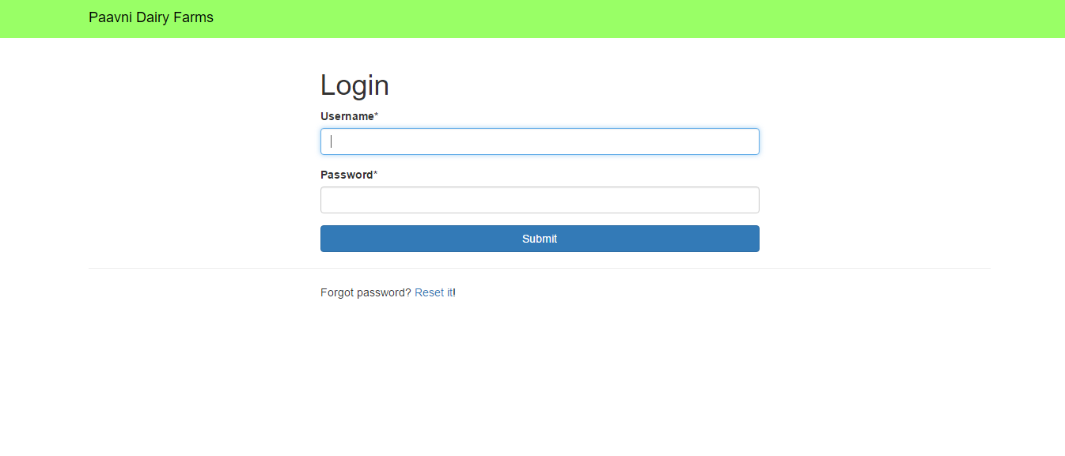
External Interface Requirements

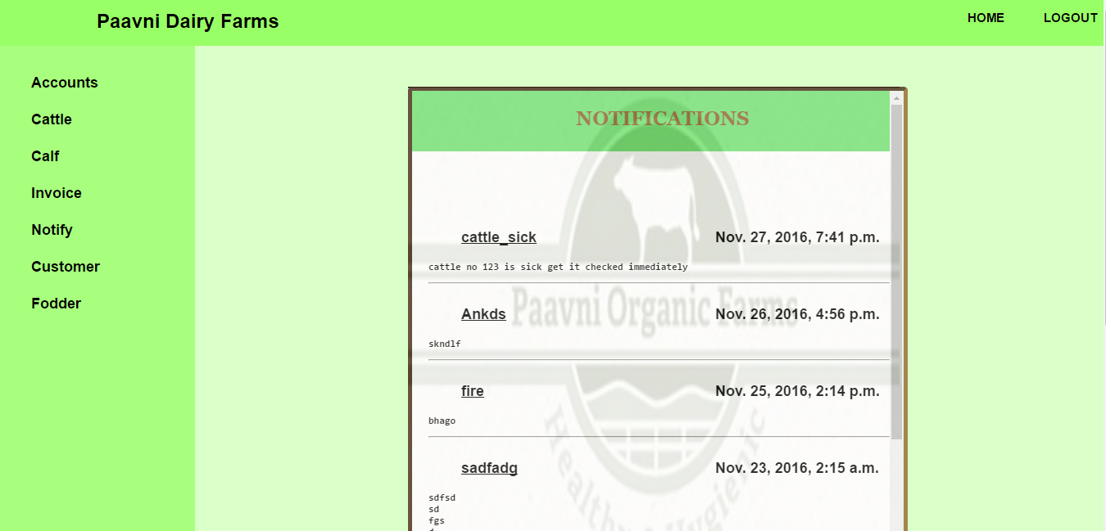

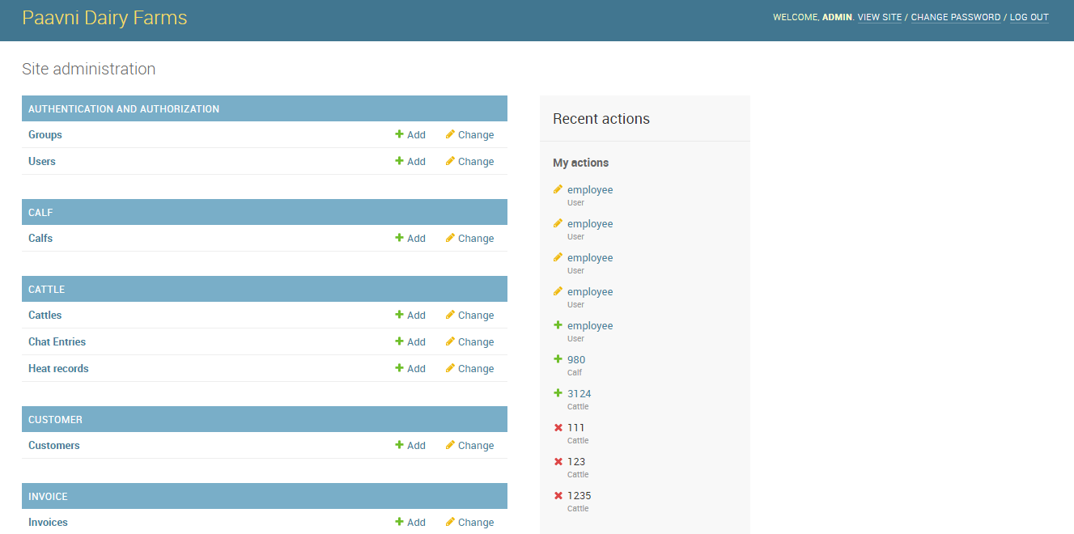

User Interfaces

- The index page of the ERP portal is a login page that directs the user to the main system page. An error will be displayed if the login is unauthorized.
- In the main system page, there will be a navigation bar which will have options of logout.
- There will also be a vertical navigation bar with certain options which are
  - Database, which when chosen, will direct to another page.
  - Create more users, where the accessibility rights will be given to the employees.
- On the right side of the page, there will be a section for daily updates and emergency alerts, along with an option to add or edit them. There will also be a reminder system that will automatically add certain required updates here.
- In the database page, the navigation bar on the left side of the page will contain the list of various databases which are
  - Cattle database – It will have set of information such as cattle id, name, breed, age, sex, etc.
  - Fodder database – The various fields here will be type of seed, fertilizers used, irrigation, harvest, etc.
  - Customer database – Here, the data on each and every customer will be stored. The data will include customer id, name, address, contact info, purchase info, etc.
- Each and every field can be updated by the admin. The options available to the other users will be decided by the admin.
- The product store will have a navigation bar at the top which will have search, signup and login.
- The page will have a list of all the available products along with add to cart option.
- In the view cart section, there will be a checkout option, which can only be accessed after login, and will direct the customer to the payment portal.
- The payment receipts will be sent to the customers via email.

Hardware Interfaces
The ERP system will work on PCs, laptops and tablets which has HTTP supporting browsers. Other than this there is not much hardware interface required.

Software Interfaces
We are using HTML, CSS, BOOTSTRAP, and JAVASCRIPT to control the interface of the website, and Python and Django for the backend developing.
We are using MySql for the database to store the Cattle, Fodder and Customer information.
It will work with all Operating systems, there is no major software constraints as of now.

Communications Interfaces
The communication standards used by us are HTTP.

System Features

REQUIREMENT IDENTIFIER | REQUIREMENT NAME | DESCRIPTION
RQ_1 | Login | Each user has to login with proper credentials to go to the Main Page
RQ_2 | Data entry into cattle database | Only Admin and authorized employees can add data into the cattle database
RQ_3 | Data entry into Fodder Database | Only Admin and authorized employees can add data to the fodder database
RQ_4 | Data entry into Customer database | Allows Admin and authorized employees to add a customer's feedback
RQ_5 | Display cattle data | All users can view the data by login in with proper credentials
RQ_6 | Display fodder data | All users can view the data by login in with proper credentials
RQ_7 | Display customer data | All users can view the data by login in with proper credentials
RQ_8 | Manage accounts | Admin can give access right to certain employees, who can then update database.
RQ_9 | Alert System | Important Notification and emergency notifications will Be posted on the Main page like for Heat notification, Pregnancy due dates, Updates on sick Cattle
RQ_10 | Update cattle data | Allows Admin and authorized employees to update the existing cattle data
RQ_11 | Notification message | Important notifications will be sent to Admin and employees
RQ_12 | Update fodder data | Allows Admin and authorized employees to update the existing fodder data
RQ_13 | Add Products to the database | Admin and authorized employees can add new items to the database which will be available for purchase
RQ_14 | Update product store | Admin and authorized employees can update production info or delete products
RQ_15 | Display products | Customers can view the products on the store page and doesn’t require to sign in
RQ_16 | Add item to cart | Customers can add products to cart
RQ_17 | Delete items from Cart | Customer can delete the products form the cart if they don’t wish to purchase that product
RQ_18 | Sign up | Customers can sign up to the website, which is a necessary condition for purchasing and updation of profile etc
RQ_19 | Sign in | Customers can sign in to the website with proper credentials
RQ_20 | Update customer profile | Customer can update their profile by signing in to the account
RQ_21 | Checkout from cart | Checkout will be directed to a payment portal
RQ_22 | Payment Of the Product | The payment Will be done through the payment portal, after which a Receipt will be sent via E-mail.
RQ_23 | Invoice creation | An invoice will be created for the purchased item, which will also be send to the customers E-mail
RQ_24 | View Purchase history | Customer can view their purchase history after signing in to the website

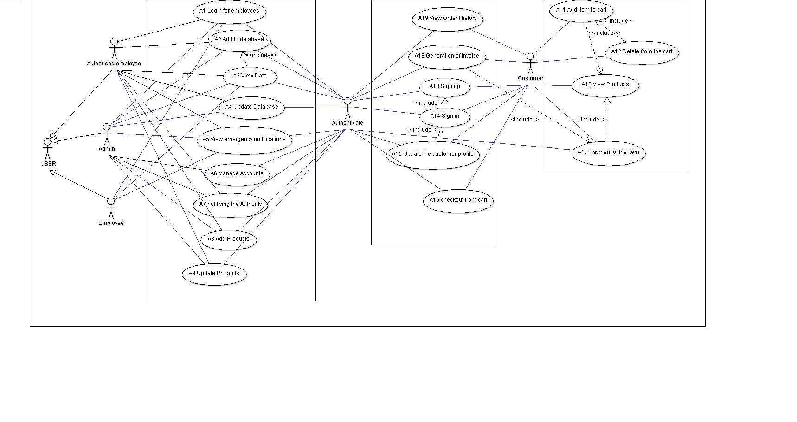
USE CASE DIAGRAM

Other Nonfunctional Requirements

Requirement Id | Name | Description
N_RQ_1 | Performance requirement | This defines that our product must work even in minimal requirements like even with slow internet
N_RQ_2 | Safety Requirements | We must avoid any kind of abrupt Crashes of server, and prevent unwanted malicious upload to database
N_RQ_3 | Security Requirements | Only users with proper access can login to the database, must prevent any kind of hacks to the system
N_RQ_4 | Quality attributes- Adaptable | Our software adapts itself very efficiently, according to the circumstances
N_RQ_5 | Quality attributes- Correctness | Generation of correct results at all times.
N_RQ_6 | Quality attributes- Availability | The product is easily available to the user via internet
N_RQ_7 | Quality attributes- Flexibility | It can be easily integrated to other system, and software is flexible to changes in the functionality
N_RQ_8 | Quality attributes- Maintainability | With any future changes that has to be made, it won’t affect the architecture of the product
N_RQ_9 | Quality attributes- Testability | Developers can easily test the software
N_RQ_10 | Quality attributes- Usability | Users can be able to use the product very easily, with help of the user manual which will be provided along with the software

